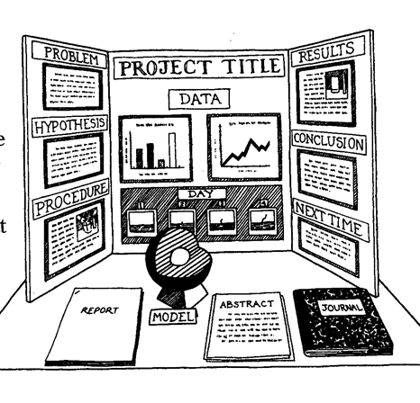

Science Fair | Heritage Fair
Problem – Driving question | Topic Question- What are you wondering about?
Hypothesis - prediction | What do I already know? What do I want to find out?(K/W)
Procedure-how will you test your prediction? | Action/Research
Results-What happened? | What I Learned (L)
Conclusion – What do the results mean? How does this reflect on your hypothesis? | Conclusion – Summarize what you discovered. How does this reflect on your initial question?
Next Time – What might you change? | Reflection –What do your findings mean to you? To your community? Your province? Your country?

